EXPERIMENT 1

ER DIAGRAM OF COLLEGE DATABASE

**Aim:** Draw an ER diagram of a college database.

**Components:**

* Entities:
* Strong entity:
  + Studies in
  + Taught by
  + Provides
  + Offers (Weak relationship)
* Relationship
  + Studies in
  + Taught by
  + Provides
  + Offers (Weak relationship)
* Attributes
  + Multi valued
    - Mobile
  + Composite
    - Address
  + Primary
    - Stud_id
    - College_id
    - Faculty_id
    - Course_id

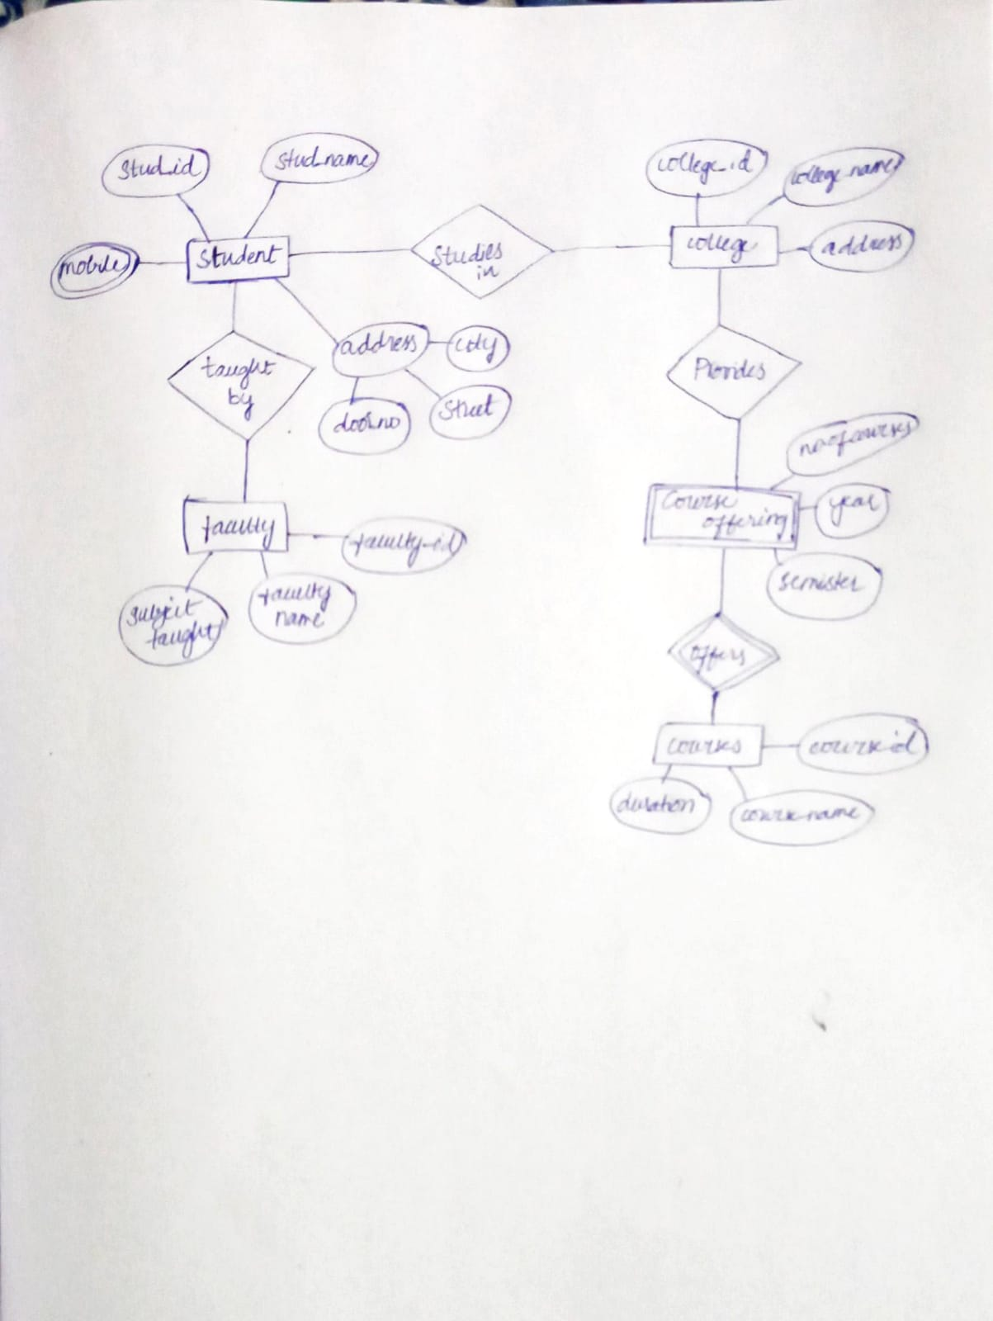

offers

Course

Course offerings

Faculty

Taught_by

Prov-ides

Studi-es_in

Student

College